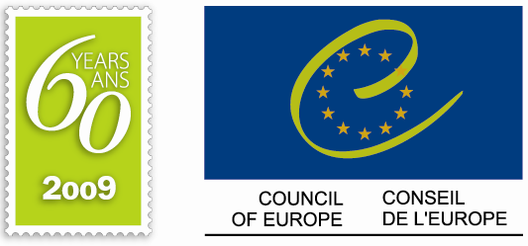
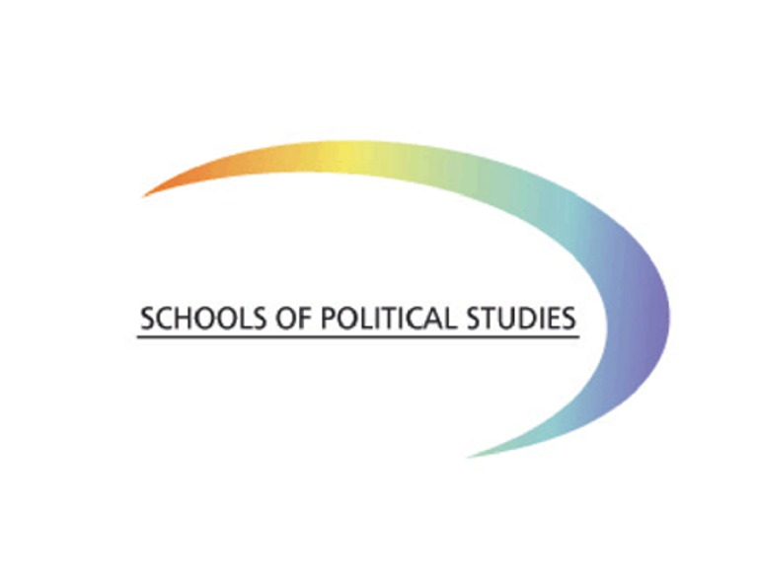

FINAL DECLARATION

4TH SUMMER UNIVERSITY FOR DEMOCRACY
Strasbourg, 6-10 July 2009

In this year, which marks the 60th anniversary of the Council of Europe and the 20th anniversary of the fall of the Berlin Wall, we, the participants from the Council of Europe’s Schools of Political Studies, have reaffirmed our commitment to democratic values and principles such as the rule of law, good governance, protection of human rights, respect of identities and sovereignty, tolerance and human dignity. These values and principles became the cornerstone for the democracies that emerged in Europe after the fall of the Berlin Wall and we hope that the peoples of Europe will continue to uphold them.

We, the participants of the Fourth Summer University for Democracy, gathered from 6 to 10 July 2009 in Strasbourg to analyse and identify how, as the new generation of leaders, we could better work together to meet the main challenges of our time:

CONSEQUENCES OF THE FINANCIAL CRISIS ON DEMOCRACY

Despite the consequences of the financial and economic crisis on the functioning of democratic institutions, we are committed to the liberal economic system. Nevertheless, we should work together on establishing new mechanisms that would provide effective instruments of control over financial institutions. We would like to point out that today's crisis is not purely financial or economic in nature, but first and foremost a global crisis of values and trust of business, financial, and political leaders.

We must heed the strong voice of citizens demanding everyone, including intellectuals, to put their heads together to devise new ways of behaving at all levels – individual, national, regional and global – to introduce ethics, accountability and responsibility in their actions and their behaviour.

We consider that for all of our countries further European co-operation remains the key factor for peace and stability and a driving force for economic and social prosperity.

IDENTITY CRISIS, INTERNATIONAL VIOLENCE AND THE RULE OF LAW

Democracy is challenged by both the global economic crisis and identity crisis. Each of us has a plurality of identities, on which we build our future and that imposes us to respect our neighbours.

We believe that democracy has to be strengthened by the fight against international violence, stronger involvement of civil society and participative democracy at all levels. Terrorism is a criminal activity and can never be a political means of action. There cannot be any justification in using terrorist acts to solve the world's problems, or to impose one's identity to others. In this regard, when fighting terrorism, our societies must always respect all the fundamental rights, as defined by the European Convention on Human Rights and the case law of the European Court of Human Rights. We encourage the promotion of different forms of dialogue between communities and stakeholders.

Only through respect for diversity can society promote democracy, freedom and welfare for citizens. In this respect, organised crime, corruption and trafficking of all kinds constitute real threats to society and we call upon our governments and the international community to increase their co-operation and efforts.

We welcome the important contribution of the Council of Europe in all these matters and express our strongest support for this Organisation in its continued efforts to promote pluralist democracy, human rights and the rule of law.

ENVIRONMENTAL CHALLENGES AND POLITICAL PRIORITIES

We, the participants of the Fourth Summer University for Democracy, believe that all people should have the same right of access to natural resources and energy. We believe that we are creating a welfare society, not only for ourselves but for the generations to come. The development of our society has shown necessity to adapt legal instruments for the protection of human rights, in order to extend the field of protection to the new generation of fundamental rights such as: the right to a clean environment, social rights, the protection of intellectual and privacy rights, bioethics, the rights of embryos, the use of communication technologies.

It is our responsibility to find solutions to the emerging environmental problems, in order to avoid their impact on security, peace, nature as well as to the survival of the whole of mankind.

Today, we see a growing awareness among people to search for answers, but a still comparatively low level of readiness to do so. Human resources gives us, together with technologies and know-how, promising possibilities to reverse the process of the self-destruction of our planet. Within this perspective, information and education are essential, as well as co-operation between economic leaders and society. However, corruption and fraud can affect decision-making and can make additional obstacles for sustainable development, preventing the preservation of the balance between the human race and Mother Nature.

RECOMMENDATIONS AND ACKNOWLEDGEMENTS

We, the participants of the Fourth Summer University for Democracy, believe that global challenges to democracy should be faced through advocating the rule of law and re-thinking the values that prevail in our world. The purpose of all public action should always be human beings. Responsibility and accountability must guide the new generation of leaders at local, as well as at national and international, level.

We would like to express our gratitude to the Council of Europe, the European Union, the French Government, the City of Strasbourg, the Conseil Général du Bas-Rhin and the Conseil Régional d’Alsace for supporting the network of the Schools of Political Studies, in particular the Summer University for Democracy.

We express our most sincere gratitude to the eminent personalities, speakers, experts and institutions who have selflessly contributed to making these past five days of discussions into an amazing opportunity for sharing experiences and ideas.

We would like to welcome the participation of our colleagues from Africa, within the framework of co-operation between the Council of Europe and Organisation Internationale de la Francophonie. This illustrates the universal character of the principles of democracy and the growing interest that the network of the Schools of Political Studies generates in Europe and beyond. We strongly look forward to reinforcing this co-operation in the future.

In this context, the establishment of the European Association of the Schools of Political Studies will continue to develop this unique project into a more extensive event at the international level and will reaffirm Strasbourg’s global position as the Capital of Democracy and Human Rights.

We, the participants of the Fourth Summer University for Democracy, invite the Council of Europe and its partners to renew the successful experience of the first four Summer Universities and look forward to the Fifth Anniversary Summer University for Democracy in July 2010.

Strasbourg, 10 July 2009

